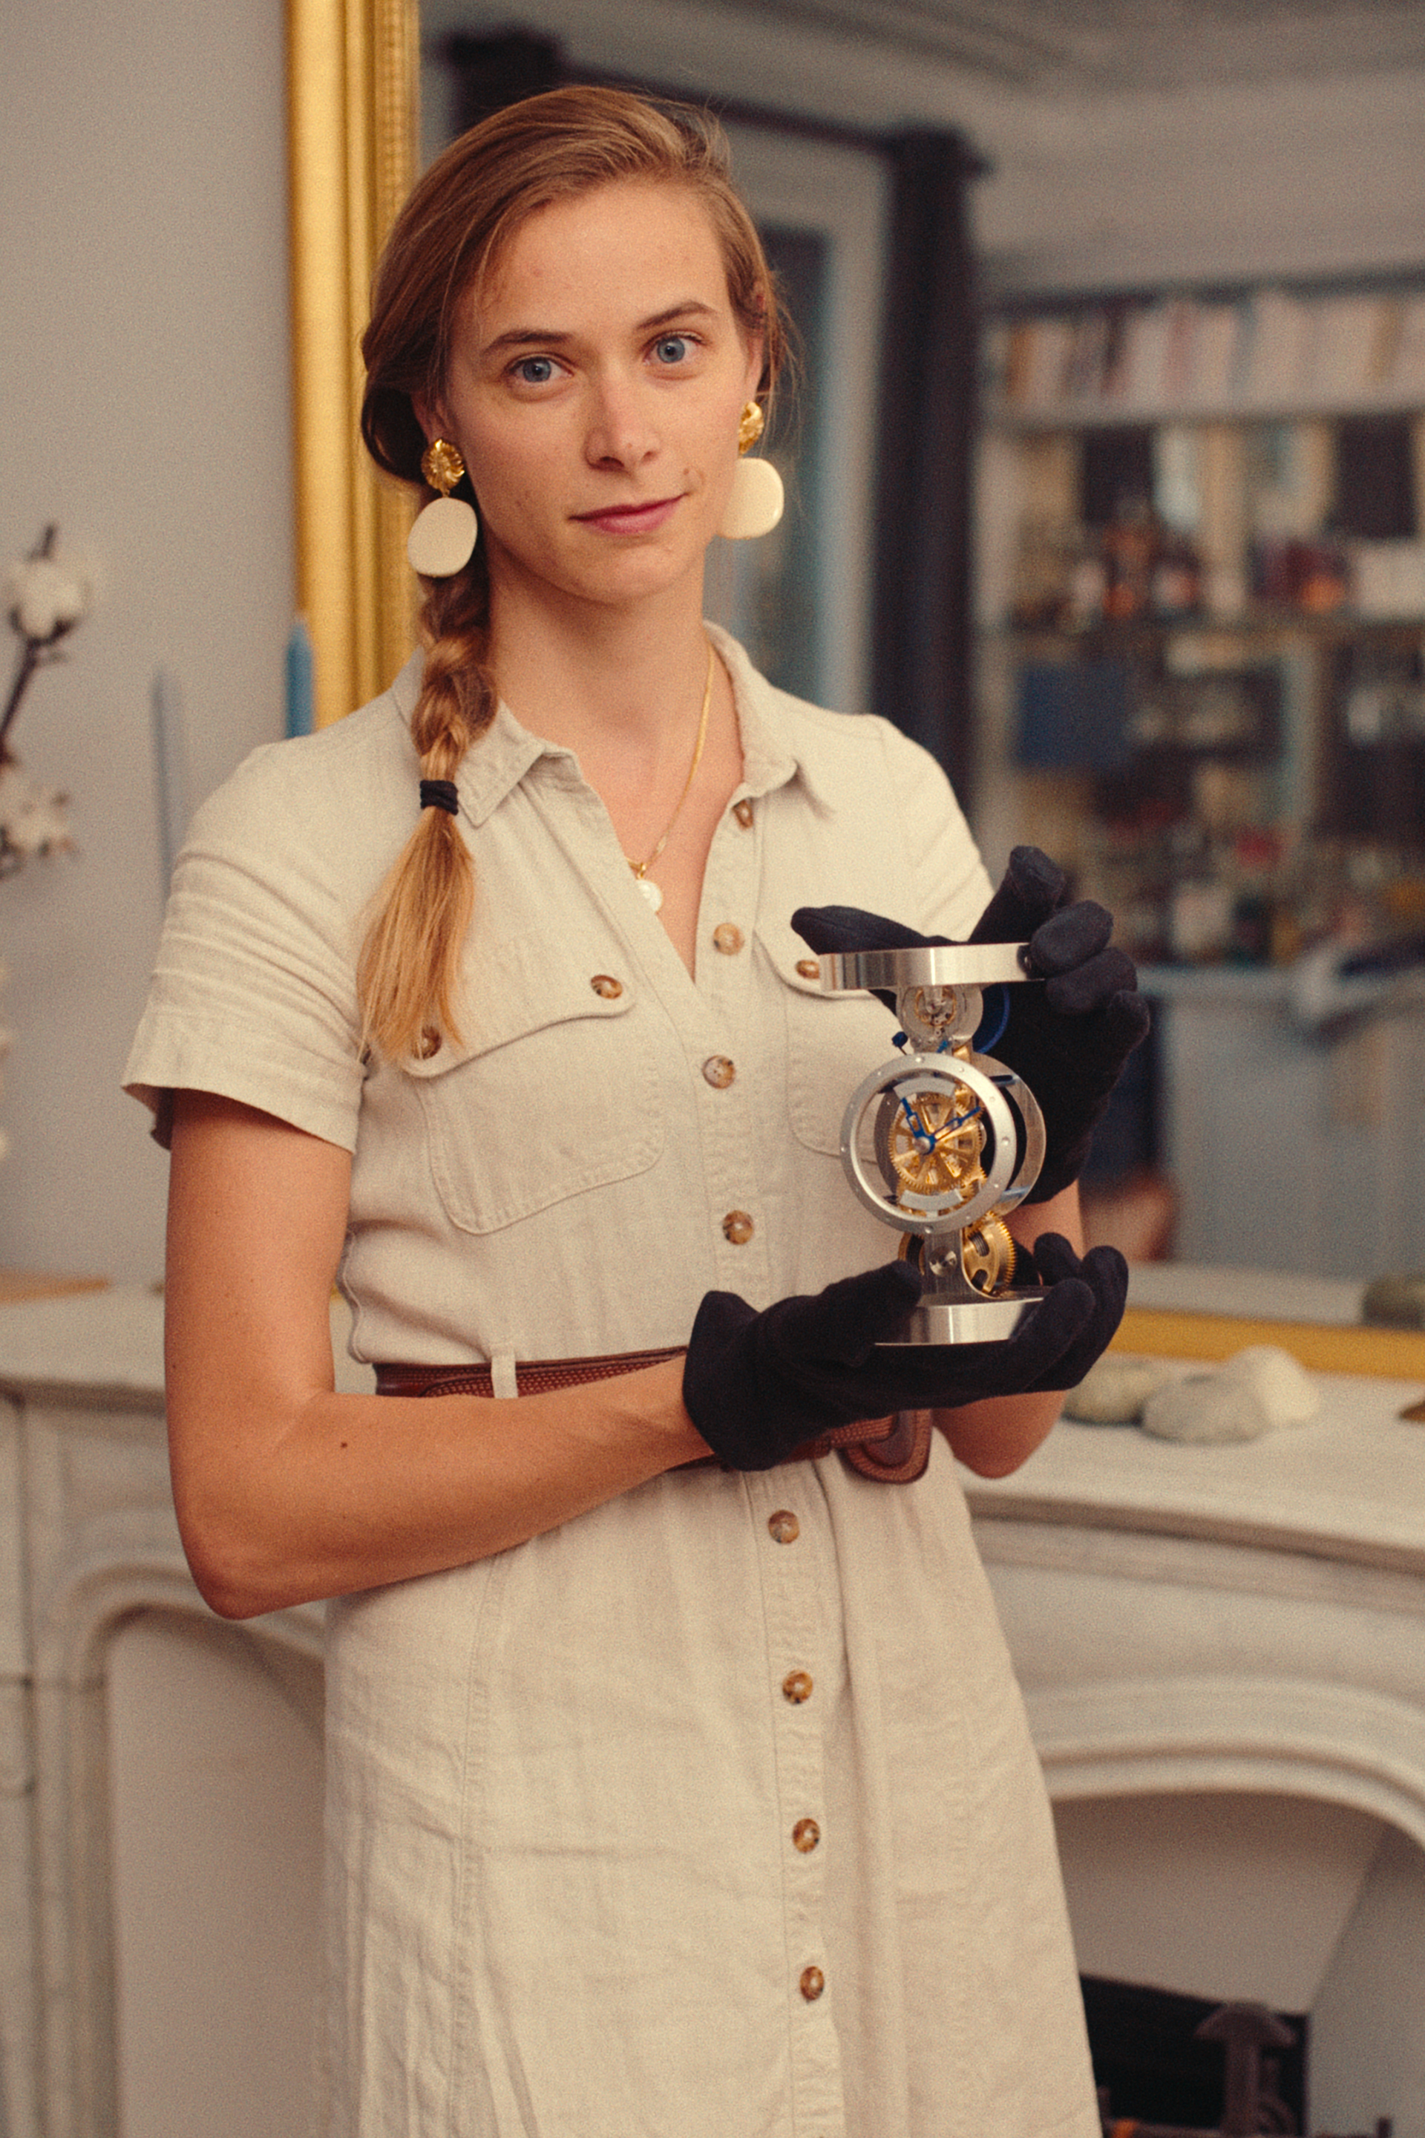

“A new, hands-on approach to luxury”
Alcée Montfort (founder)

2013 Discovered luxury craftsmanship at the Hermès silk and leather workshops
2015 Earned an engineering degree specialising in fundamental physics
2015 Worked in the supply chain of the eyewear department of Cartier
2015 Worked at the antique watch restoration workshop of the Richemont Group
2017 Became head of the movement assembly workshop of Tag Heuer, LVMH

The third of five children, Alcée Montfort was born in L’Isle d’Espagnac near Angouleme in Charente, France. As a child, she travelled with her father on his business trips across France, and developed a true passion for manual crafting. Born to a family of engineers, she herself chose the “royal path” and specialised in fundamental physics. However, her natural curiosity and manual dexterity were difficult to reconcile with such a theoretical area.
Torn between a scientific career and her manual skills, she discovered luxury craftsmanship in 2013 when she landed a work placement at Hermès: first in the silk workshops, then in the leather workshops. That was a revelation. Working with pluridisciplinary teams, she provided the craftsmen with methodical discipline and scientific solutions to assist them in resolving issues with swathes of colours or leather markings. Encouraged by this first assignment, she applied for a position at Cartier in 2015 where she learned everything there is to know about supply chain management as part of the eyewear department. She went on to work at the antique watch restoration workshop of the Richemont Group, and in 2017 she became the movement assembly workshop manager for Tag Heuer at LVMH.

When she became a mum in 2019, she took a break from her career to embark upon a personal project that had been consuming her for several years: to enable aficionados to step into the shoes of a watchmaker to assemble their own unique, personalised, numbered timepiece. She surrounded herself with a team which included, among others, a “Meilleur Ouvrier de France” watchmaker who provides input on luxury craftsmanship; watchmaking professors for an educational dimension; and a timepiece designer who brings a fresh perspective on a product that might otherwise appear outdated. And so she founded Maison Alcée and presented Persée, the first luxury desk clock to assemble at home.

In the future, Alcée Montfort would like for Maison Alcée to become the French reference in luxury DIY, as she plans on developing artistic craftsmanship, in a broader sense, and in particular silk work.

Photos

Media contact:
DC-AGENCIES Genève-Paris
Anaïs Georges Duclos
anais.georgesduclos@dc-agencies.com
Genève +41 79 800 70 84 / Paris +33 6 69 76 99 85

