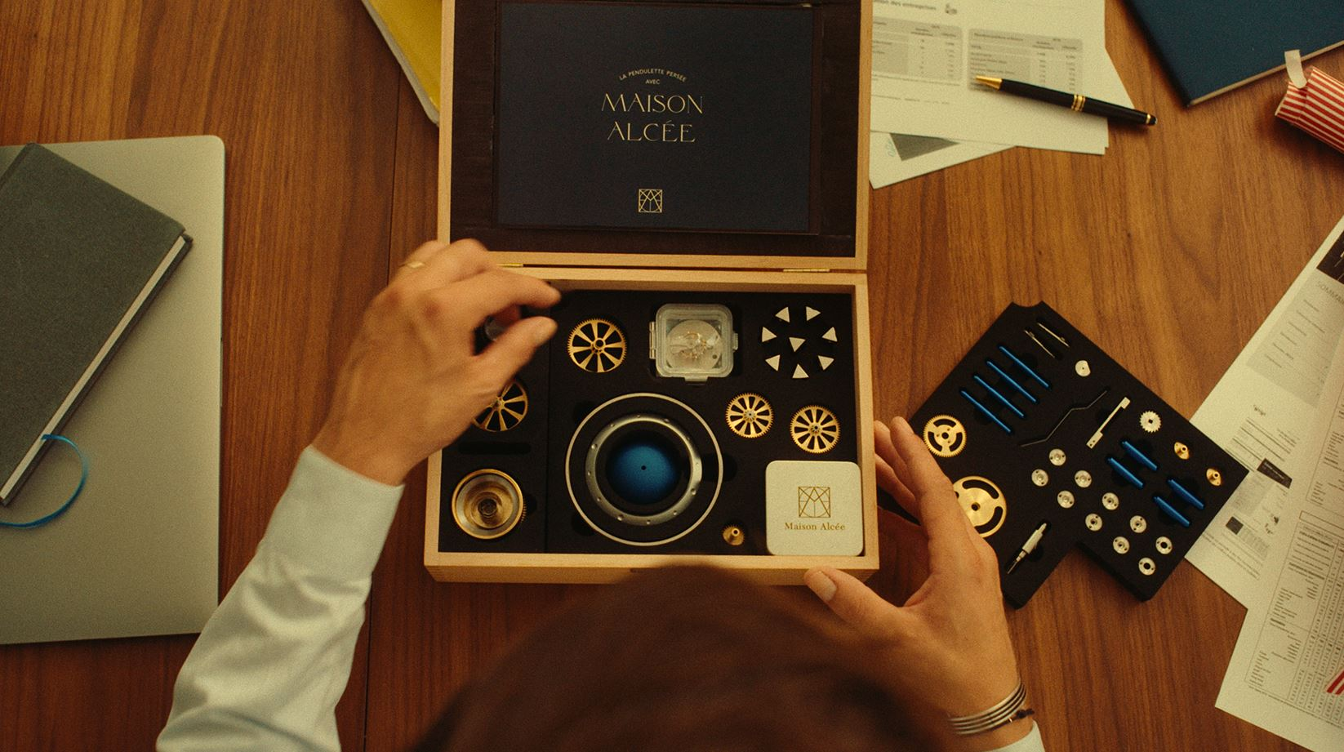
A unique experience in the world: Maison Alcée watch box set
Geneva, from August 29th to September 1st 2023

"Maison Alcée does not simply propose you to own a clock, it offers you a unique chance to make it yourself. It is an experience to share and a legacy to pass on."
Alcée Montfort, founder

Founded in 2019 by Alcée Montfort, Maison Alcée is a young French watchmaking house based in Reims. In 2022, after three years of research and development, it launched a unique watchmaking box in the world. It contains the 1st « do it yourself » luxury clock with hourly chime, including a mechanical movement.
In August 2023, it will be presented for the first time in Geneva.

Over 95% of the products are made in the Swiss-French Jura Arc region.
50 pieces have already been sold in less than a year.
A new series of 100 is in production.
New complications will soon be available.

An unprecedented clockmaking experience
Maison Alcée proposes an unprecedented clockmaking experience: the assembly of a table clock, presented in a solid wood case. When an owner lifts the lid on this finely crafted solid wood case, they can be sure they will experience what Maison Alcée promises: the joy of creating something and coming as close as possible to capturing the craftsman’s skill and its full meaning.

An initiatory book
Each case contains an artistic book that tells the tale of centuries-old clockmaking know-how.
This beautifully written hundred-and-fifty-page work, a handbook for the clockmaking apprentice, is not just a user manual: it is an integral part of the set and the experience. It not only contains instructions for assembling the table clock and distinguishing among the some hundred tools and components (bridges, baseplates, keys, dome, etc.) throughout the process. It also embarks the reader on the discovery of clockmaking history and savoir-faire through a number of authentic anecdotes.

Professional clockmaking tools for use by neophytes
In keeping with the complexity of clockmaking, which has been called “the profession of a thousand tools”, the Maison Alcée set contains everything required for the assembly of the Persée desk clock: a clockmaker’s magnifying glass, tweezers, four screwdrivers, finger cots, a membrane case, a chamois cloth, a small oiler, and more. Some of these tools have been specially adapted to facilitate their use by neophytes.

Exceptional clockmaking designed for aficionados: A house mechanical movement developed by and for Maison Alcée
The case also contains the 233 components of the mechanical movement that make up the Persée desk clock, which the Maison Alcée team developed especially for assembly by novices.
It was designed in collaboration with Antoine Tschumi (a Swiss timepiece designer), Thierry Ducret (a French watchmaker with the title “Meilleur Ouvrier de France”), and the watchmaking professors of the prestigious Ecole de Morteau in French Jura, who are well-acquainted with the difficulties that their first-year students encounter. Only the regulating organ is pre-assembled.
Intemperate collectors, incorrigible enthusiasts or insatiable neophytes will all become heirs to an age-old discipline for a brief moment, finally feeling the pride of making something with their own hands.

The renewal of French clockmaking in the Franco-Swiss Jura Arc
More than ninety-five percent of the value in these pieces is created in the Franco-Swiss Jura Arc, of which the mechanical clockmaking and artistic mechanical savoir-faire joined UNESCO’s Intangible Cultural Heritage list in December 2022.

Video « Time that stays » (long version - 2min40)
Video « Time that stays » (short version - 1min)
Video of the 1st step of the assembly
Video of final adjustments (early-late)
Photos

Media contact:
DC-AGENCIES Genève-Paris
Anaïs Georges Duclos
anais.georgesduclos@dc-agencies.com
Genève +41 79 800 70 84 / Paris +33 6 69 76 99 85

